

|  |  |  |  |  |  |  |  |  |
| --- | --- | --- | --- | --- | --- | --- | --- | --- |
|  | | | | | | | | |
|  | | Global Socio-Economic Analysis: GDP, Happiness, and Trade | | | | |  | |
|  |  | | | | | | |  |
|  | | | |  |  | | | |
|  | | | | Rachel Heke |  | | | |
|  | | | | 14/11/2023—PST107 Probabilities & Statistics—Sherry Feng |  | | | |
|  | | |  | | |  | | |



|  |  |  |  |  |  |  |  |  |
| --- | --- | --- | --- | --- | --- | --- | --- | --- |
|  |  | | |  |  | | |  |
|  | INSTRUCTIONS | | | | | | |  |
|  |  | | |  |  | | |  |
|  |  | |  | | |  | |  |
|  |  |  | Report: Written document containing all relevant information such as • Dataset information • Tools & libraries used • Algorithms • Motivation/Background • Hypothesis • Findings • Pipeline/process • Visualizations • My opinion • Reflections/future – what you would do next / could’ve done better | | |  |  |  |
|  | | | | |
|  |  |  |  |
|  |  |



|  |  |  |  |  |  |  |  |  |
| --- | --- | --- | --- | --- | --- | --- | --- | --- |
|  | |  |  | | |  |  | |
|  | | THE PROCESS | | | | |  | |
|  | |  |  | | |  |  | |
|  | Dataset Information: The analysis employed four primary datasets:   * **Countries.csv**: Contains socio-economic indicators for various countries, including GDP and GNI per capita. * **Region.csv**: Provides happiness scores and related metrics across different world regions. * **WHR2023.csv**: The World Happiness Report of 2023, offering comprehensive data on global happiness indices. * **world-data-2023.csv**: Encompasses a wide array of socio-economic and environmental metrics for each country.   These datasets were sourced from Kaggle.com credible global database, ensuring the reliability and accuracy of the information provided. | | | | | | |  |
|  | Tools & Libraries Used: The statistical analysis was conducted using R, a powerful language and environment for statistical computing and graphics. Key R libraries used in the analysis include:  stats: For performing linear and multivariate regression.  ggplot2: For creating advanced visualizations.  dplyr: For data manipulation and cleaning. | | |  |  | | |  |
|  | **3. Algorithms:** The primary statistical method applied was linear regression, used to model the relationship between the independent variable (GDP per capita) and the dependent variable (happiness scores). For multivariate analysis, multiple regression was used to incorporate additional control variables. | | |  | **4. Motivation/Background:** Given the increasing interest in the determinants of national happiness and well-being, this analysis aimed to understand how economic prosperity, represented by GDP per capita, correlates with and potentially influences happiness levels across nations. | | |  |

|  |  |  |  |  |  |  |
| --- | --- | --- | --- | --- | --- | --- |
|  |  | | | | |  |
|  | |  |  |  |  | |
|  |  | | | | |  |

**5. Hypothesis:** The central hypothesis was that higher GDP per capita is positively associated with higher happiness scores, suggesting that economic health is a significant predictor of well-being.

**6. Findings:** The linear regression analysis confirmed the hypothesis, revealing a strong positive relationship between GDP per capita and happiness. The introduction of control variables such as life expectancy and social support also showed significant associations, indicating that happiness is a complex phenomenon influenced by multiple factors.

**7. Pipeline/Process:** The analytical process involved:

* Data loading and inspection.
* Merging datasets based on common 'Country' identifiers.
* Cleaning and pre-processing data to ensure consistency and accuracy.
* Exploratory Data Analysis (EDA) to visualize preliminary relationships.
* Statistical testing to quantify the relationships between variables.
* Extensive multivariate analysis to control for confounding factors.

**8. Visualizations:** Visual aids included scatter plots with fitted regression lines to illustrate the relationship between GDP per capita and happiness, bar plots for regional comparisons, and tables summarizing regression results.

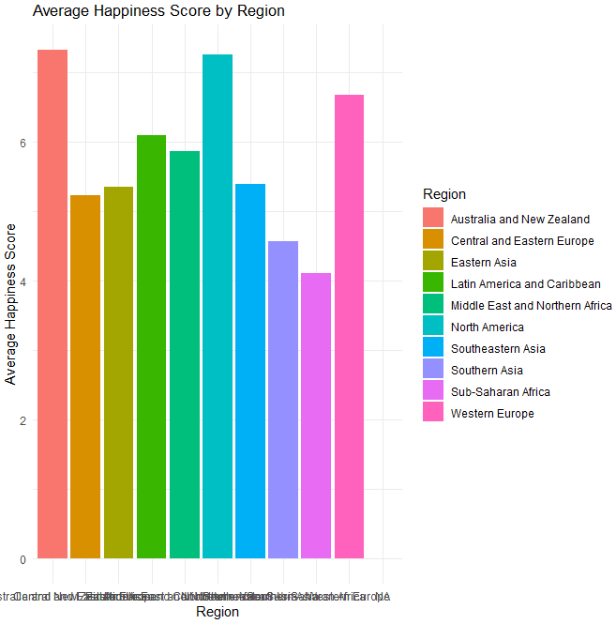

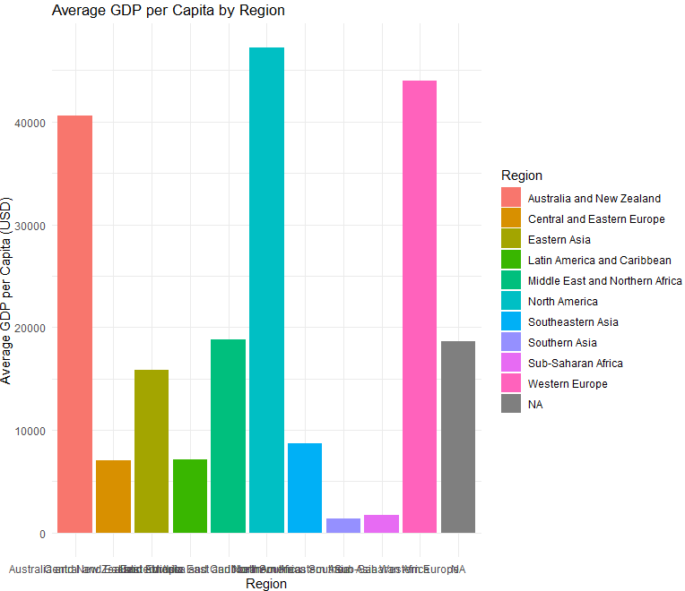

**9. My Opinion:** The results compellingly suggest that while economic factors are significant, they do not capture the entirety of what contributes to a nation's happiness. The policy implications are clear: governments should adopt a holistic approach to development that encompasses economic, social, and personal well-being.

**10. Reflections/Future – What You Would Do Next / Could’ve Done Better:** Future research should explore other potential predictors of happiness, including cultural and environmental factors. Additionally, the analysis could be improved with a larger dataset, encompassing more countries, and spanning a longer time frame to track changes over time.